Honorlock Tutorial for Students 2026
Beginning September 1, the Legacy Room Scan Video option within Honorlock will no longer be selectable in the same location in Settings. Honorlock is incorporating this legacy feature into the Workspace Scan Photo student workflow. Enabling Environment Integrity and Workspace Scan Photo will provide students with the opportunity to choose Room Scan Video at the appropriate point in their workflow.
These instructions explain in detail how students start an Honorlock-enabled quiz and how they complete a Workspace Scan without the use of a mobile device as part of the authentication process. Faculty may require that mobile devices be excluded from the testing environment and may require students to complete the Workspace Scan with your webcam.

Launch the Exam
Click on Honorlock 1.3 [1] in the navigation menu. Locate the exam on the Honorlock dashboard and click on the Launch button [2]. The Honorlock authentication process will begin.
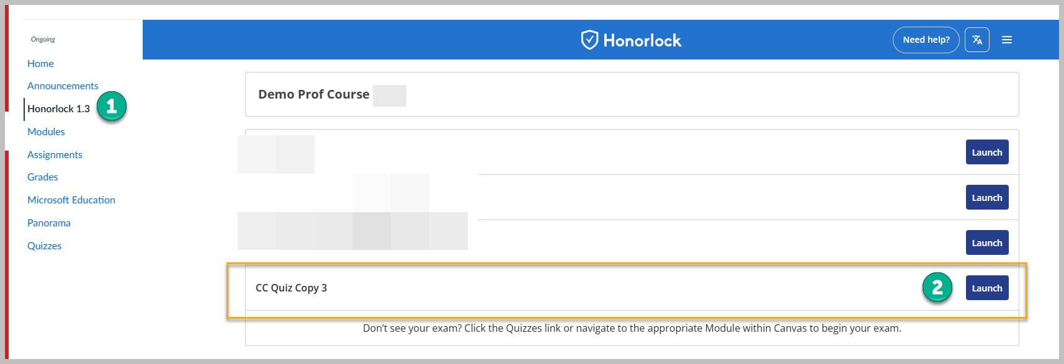
If you do not have the Honorlock Chrome Browser Extension, you will be prompted to download and install it. The Extension is required to complete the exam.

Data Collection & Use
Students are required to check two boxes:
- I agree to authorize the collection of this data [1].
- I agree to Honorlock’s Terms of Service [2].
Once both boxes are checked, you can click on the Continue to System Check button [3].
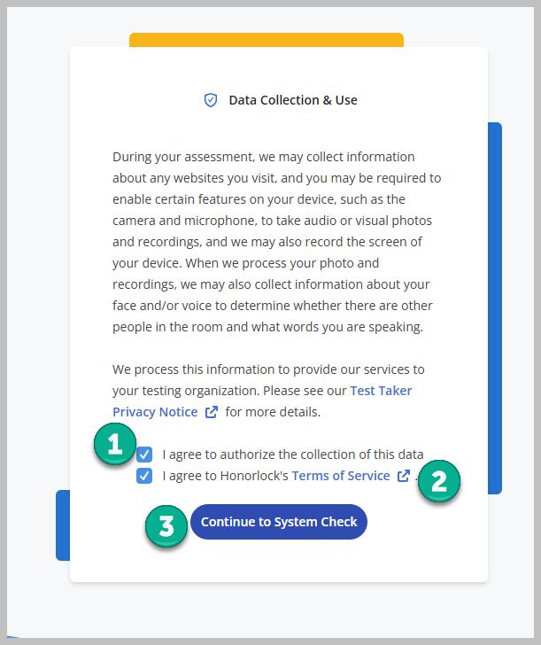

System Compatibility, Your Assessment Guidelines, Review Authentication Settings, and Honorlock Proctoring Prep

System Compatibility
Students can run the system check to ensure that their system is compatible with Honorlock. This step is optional.
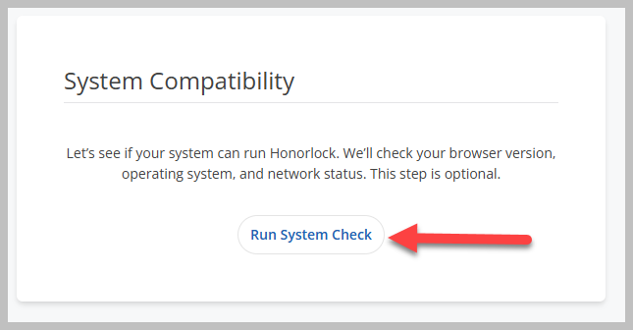
The system compatibility check analyzes the browser, operating system, and network and identifies any issues.
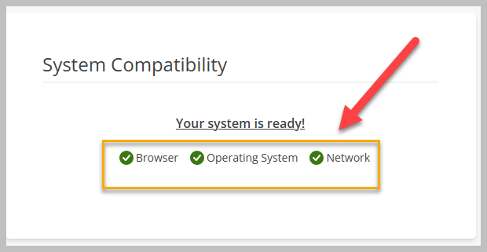

Your Assessment Guidelines
In this section, students will see the guidelines for the exam, including any direct instructions provided during the exam settings setup.
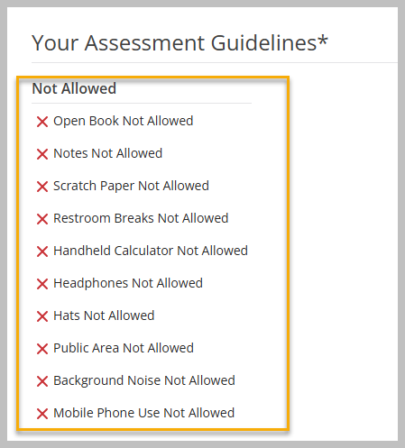

Review Authentication Settings
In this section, students will see whether a workspace scan is required for the exam.
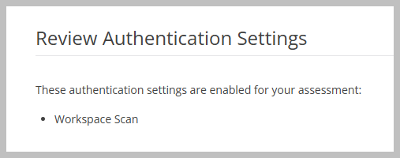
If Workspace scan is selected, students are required to record their physical testing environment. During a Workspace scan, students have the option to use a mobile device to complete the authentication process. Please be advised that faculty may require students not to use a mobile device during this process and may instead require students to record a 360-degree room scan of the testing environment with their webcam.
Instructions to complete a 360-degree room scan video are provided later in this tutorial under Begin Authentication > Workspace Check.

HonorPrep
In this section, students can click on an HonorPrep link to see how Honorlock works during an assessment. Students can view this tutorial before they begin the authorization process.
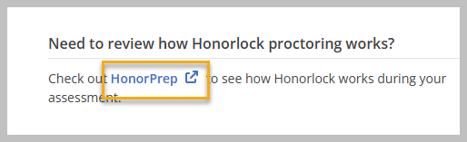
After clicking on the link, click on the Start Guided Tour Button [1].
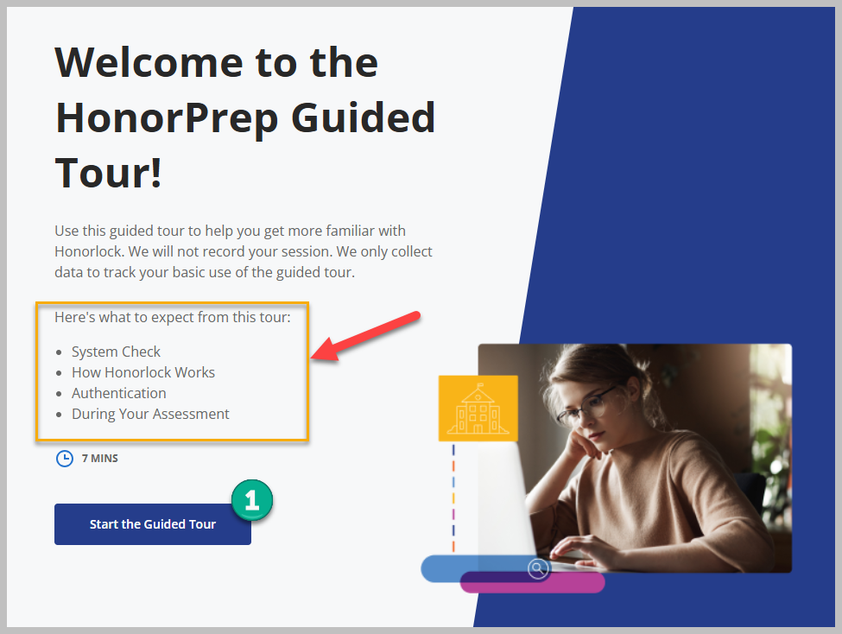
Students will be guided through a tour of how Honorlock works.
This tour, again, is optional.

Begin Authentication
At the bottom of the page, students begin the exam process by clicking on the Begin Authentication button [1].
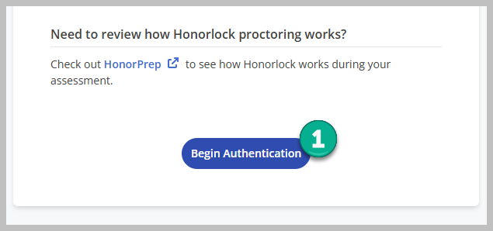

Privacy Details
Students must click on the I Understand button [1] to continue authentication.
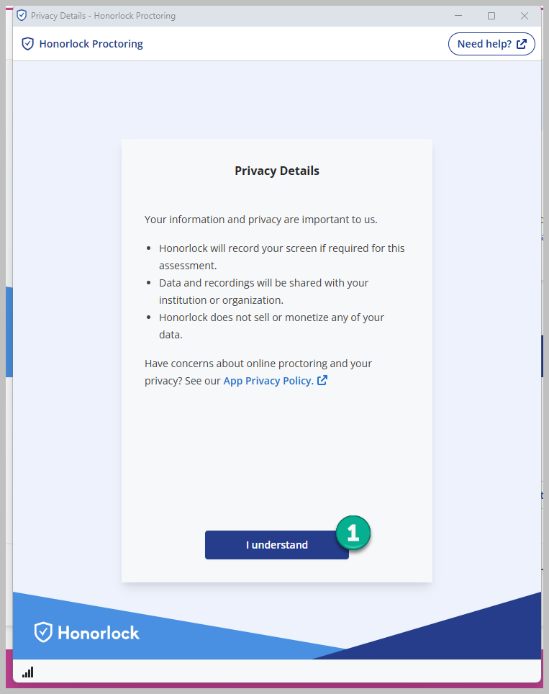
Students will complete various steps to complete the authentication process, depending on the settings selected during exam creation.
Learn more about the authentication process from the student perspective by visiting How to Complete ID verification from Honorlock resources.

Workspace Check
A recent update by Honorlock to the authentication process provides students with an opportunity to use a mobile device to complete the Workspace Check. Faculty may instruct students not to use a mobile device during the Workspace Check. Instead, instructors may require students to complete the Workspace Check without a mobile device in the testing environment.
Follow these directions if faculty allow students to use a mobile device to complete the authentication (Workspace Check) process.

Instructions to Complete a Room Scan Video for Authentication without a Mobile Device
In this section, we will demonstrate the instructions that faculty may provide to students when completing a Workspace Check without a mobile device in the testing environment.
Students, complete the Workspace Check by following these steps:
- Prepare your workspace by completing these three steps, and then click on the checkbox beside each one to confirm each step has been completed.
  - I’m taking my assessment at a table or desk.
  - I have removed clutter from my workspace.
  - I’m only using materials and devices that are allowed by my assessment.
- Then click on the Continue button.
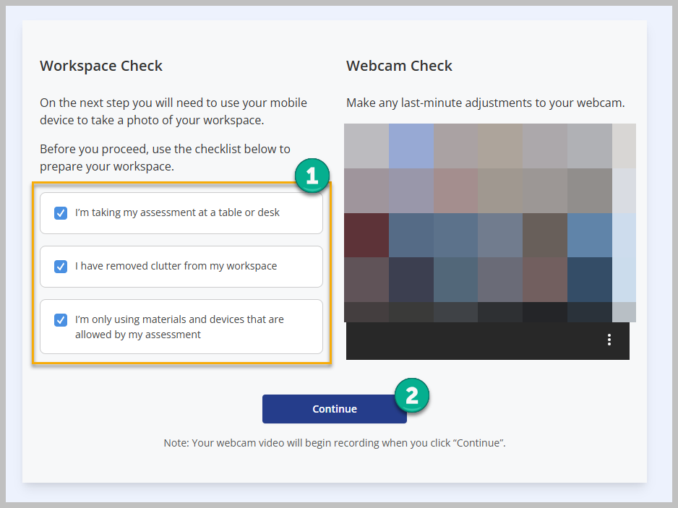
  - Do not use a mobile device to scan the room. A mobile device is not allowed in the testing environment. Mobile devices such as smartphones, tablets, watches, and laptops and any other type of mobile device are not allowed in the testing environment. Other secondary devices such as a secondary desktop computer are also not allowed in the testing environment. If secondary devices of any nature other than the testing computer are identified during testing, the instructor will use discretion in accordance with JSU’s academic honesty policy to deduct points from the test.
  - You are required to use either an external webcam or built-in PC/Mac webcam to record your testing environment. An external webcam is recommended.
- At the bottom of the screen, select Click here to submit a room scan video instead.
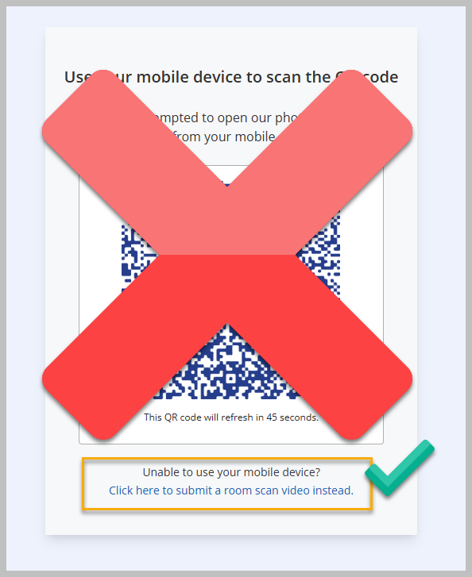
- Click on the Start Room Scan button. Use an external webcam or the internal webcam on your laptop/Mac to scan the room (testing environment). An external webcam is recommended.
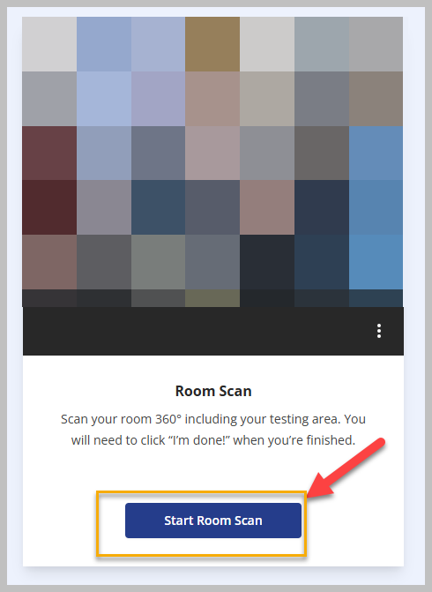
- The room scan process will begin. Use your webcam to complete a 360-degree scan of your desk, room, and testing environment. Scan the entirety of the workspace, including under your desk and behind your desk. When you are finished, click on the I’m Done! button.
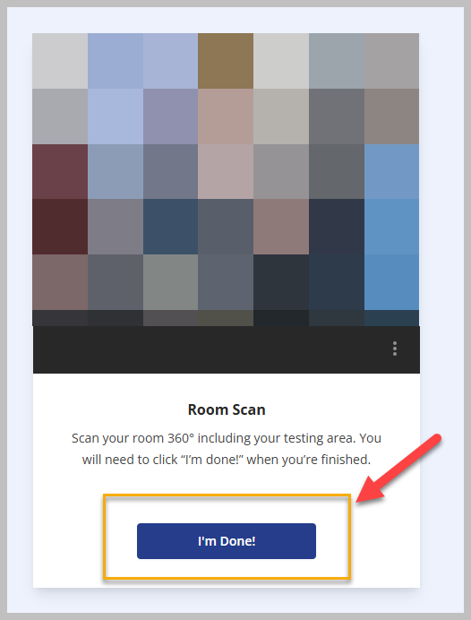
- Students can watch and review the room scan before it is submitted. Watch the scan. If the scan captured your workspace, click on the Yes, Submit button [1]. If it did not capture your workspace, click on No, Try Again [2] and complete the room scan again. Once complete, click on the Yes, Submit button [1].
  - Faculty will be able to watch the workspace scan after the exam is completed. If a complete workspace scan is not completed following the prescribed instructions, the instructor will use discretion in accordance with JSU’s academic honesty policy to deduct points from the test.
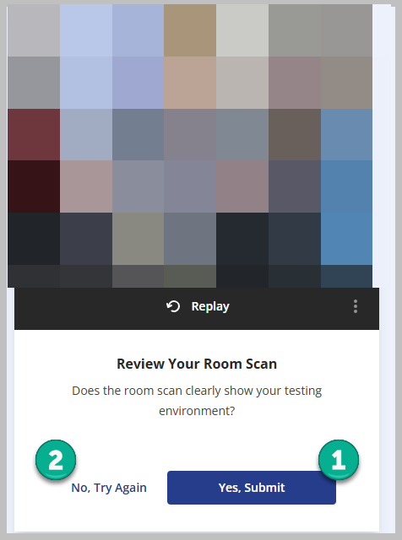

Focus Test Window
Click on the Focus Test Window.
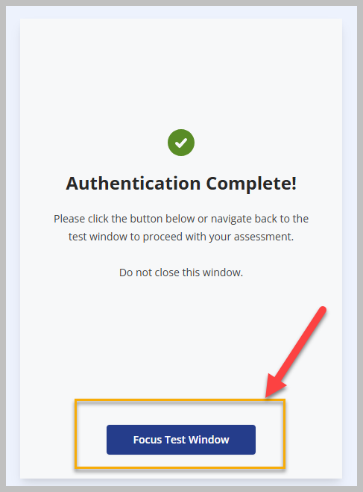

Start Assessment
Click on the Start Assessment button to begin the exam.
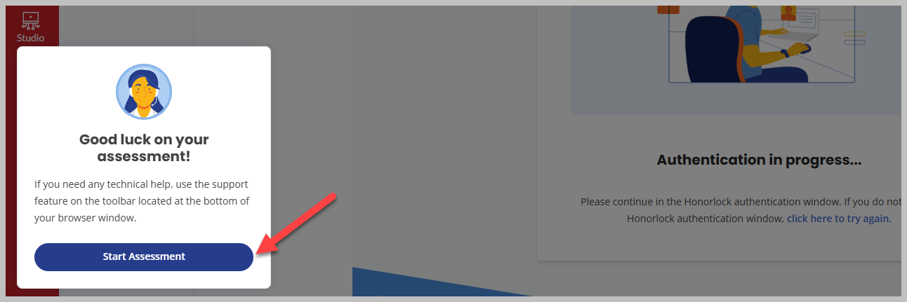
The assessment will begin.

Resources

Honorlock Help Center and 24/7 Support
- Honorlock Support Center
- Honorlock 24/7 Support – Live chat with Honorlock any time

Best Practices and Student Guidelines
- Preparing for an Honorlock Test (READ FIRST)
- HonorPrep - A Step-by-Step Guided Tour of Honorlock for Students
- Honorlock Standard Exam Guidelines for Students

Resources for Test Takers
- Test Taker Resources
- Test Taker Quick Fixes – if students run into Honorlock issues
- Troubleshooting Tips
- Workspace Scan - Test Taker Guide (If faculty allow students to use a mobile device to complete authentication (Workspace Check).

