Honorlock at Jacksonville State University

Enable Honorlock
If Honorlock is not enabled in your course:
- Click on Settings in the Course Navigation Menu
- Click on Navigation.
- Locate Honorlock 1.3 and click on the three vertical dots.
- Click on +Enable.
- Click on the Save button.
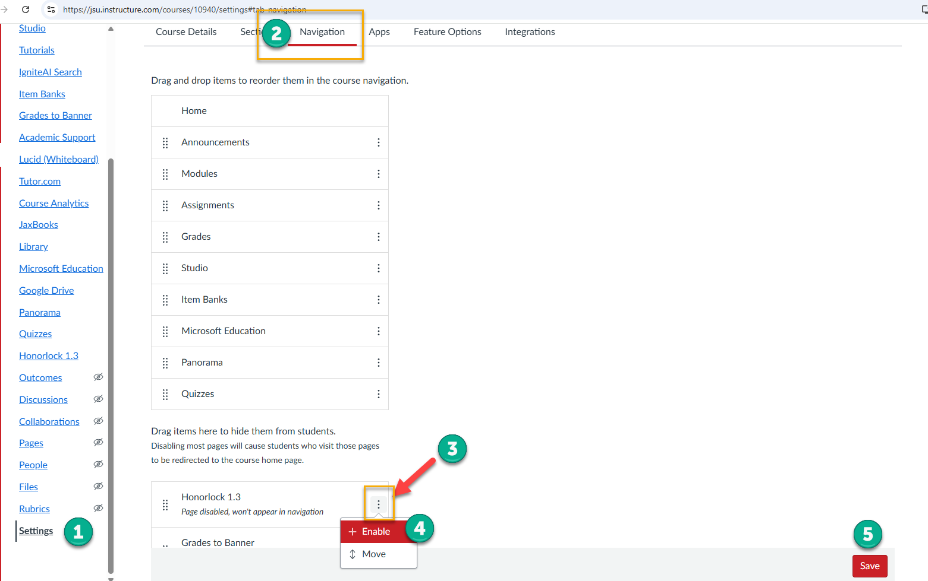

Create an Honorlock Practice Assessment
The best practice to follow is to create an Honorlock Practice Assessment. The assessment is worth 0 points and allows students to go through the Honorlock setup process so they can familiarize themselves with the authentication process in a low-stakes environment, and allows students to identify and correct any technical issues with the assistance of Honorlock Support so that potential issues can be corrected prior to the actual exam. Require students to complete the Practice Assessment at least one week prior to the scheduled exam date.

Creating the Honorlock Practice Assessment
- Click on Honorlock 1.3 in the course navigation menu.
- At the top of the Honorlock 1.3 dashboard, click on hamburger icon.
- Select Add Practice Assessment.
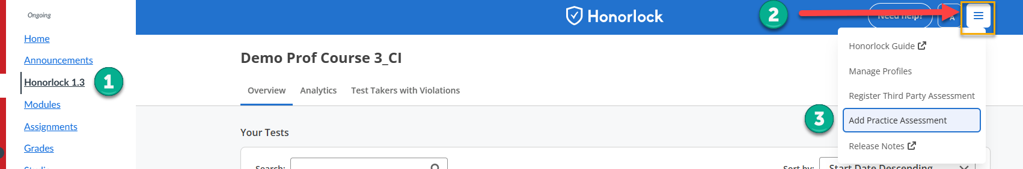
A pop-up box appears that says, A practice exam is recommended to help get you and your students familiar with Honorlock. This will create a practice exam in this course that you will need to “Click to enable [1].”
Click on the Confirm button [2].
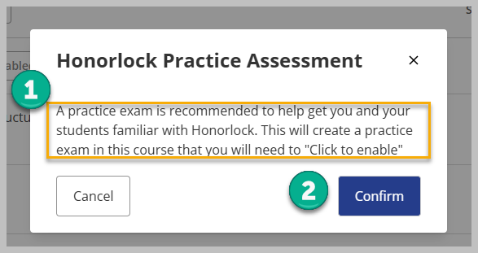
Locate the Honorlock Practice Assessment [1] on the Honorlock Dashboard and click on the Enable button [2].
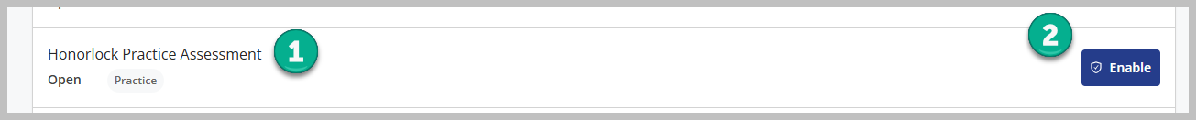
After an Honorlock Practice Assessment is generated, it will appear on the Quizzes page [1] within a group called Practice Quizzes [2].

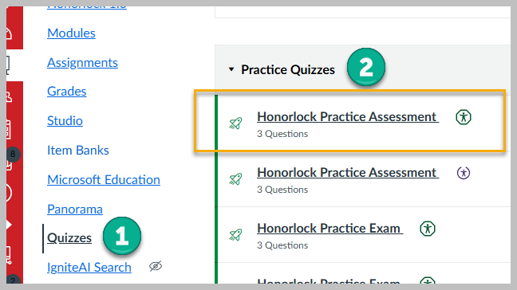
Note: An Honorlock Practice Assessment is a practice quiz worth 0 points. Therefore, it does not appear in the Gradebook.

Honorlock Text/Quiz/Exam Settings
Honorlock quiz settings for all Honorlock quizzes are the same, regardless of whether the quiz contains a point value or whether the quiz is a practice quiz.

Email Notifications
Select “Send email notifications when recommended sessions are available for this assessment [1].”
If you do not see your email address, add your email address [2] and click on the Add button [3].
You should see your email address in the text box.
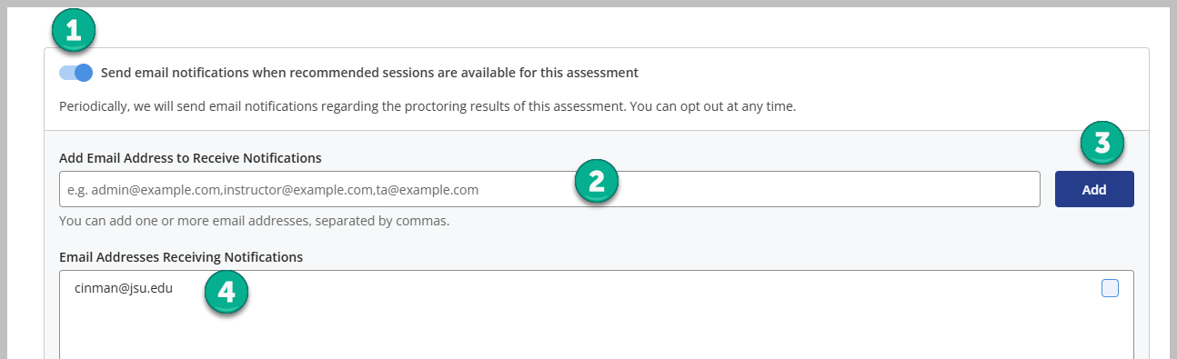

Proctoring Settings
In this section, select the proctoring settings for the quiz. For high-stakes quizzes, tests, and exams, the following selections are recommended.
- Record Webcam – Records the test taker’s environment using the webcam.
- Record Screen – Records the test taker’s screen during the session.
- Record Web Traffic – Logs the test taker’s internet activity.
- Test Taker Photo – Capture the test taker's photo before the assessment begins; this is completed with the webcam.
- Test Taker ID – Capture the test taker’s photo ID before the assessment begins; this is completed with the webcam.
- Disable Copy/Paste – Blocks any clipboard actions.
- Disable Printing – Blocks printing assessment content.
- Browser Guard – Limits browser activity to assessment content and allowed site URLs only.
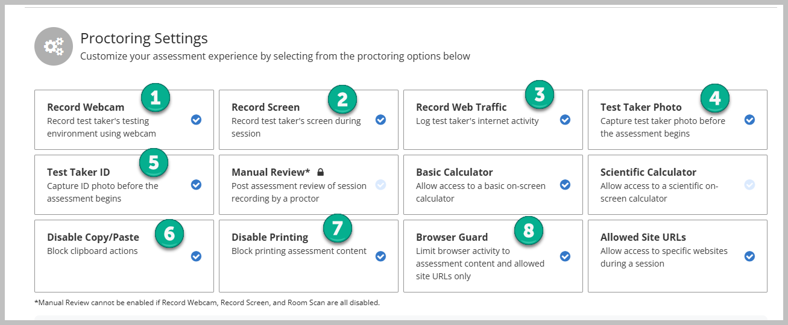
You can also enable an on-screen Basic Calculator [1] and/or an on-screen Scientific Calculator [2].
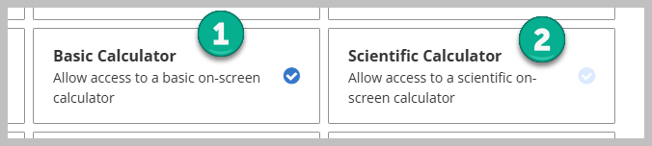
If students are allowed to navigate outside the testing environment to another, approved website during the exam you can select Allowed Site URLs [1], type the full website URL in the Configuration box [2], and then click on the Add Site button [3].
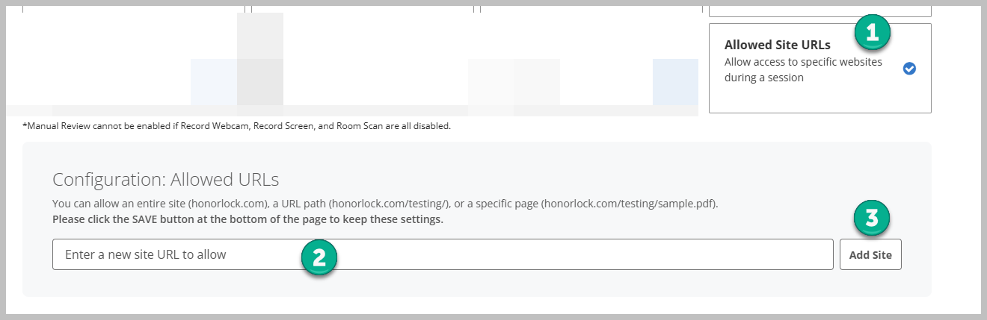
Note: JSU does not have access to Manual Review under Proctoring Settings.

Environmental Integrity
Environmental integrity requires test takes to capture their workspace during the authentication process.
Note: The traditional Room Scan Video will be discontinued by Honorlock on September 1, 2026. However, students will still be able to complete a room scan with the option, Workspace Scan Photo. Instructions for how to complete a room scan during Workspace Scan Photo are provided later in this tutorial.

Figure 1: The traditional Room Scan Video Ends on September 1, 2026
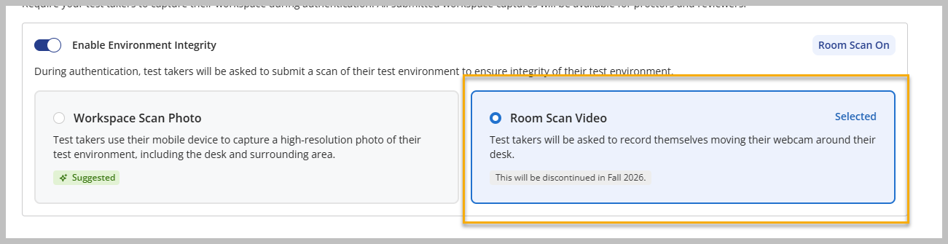
Requiring an environmental room scan is not required but recommended.
To enable Environment Integrity, click the slide button next to Enable Environment Integrity [1]. Select Workspace Scan Photo [2].
When enabled, a notification appears [3]: When Workspace Scan Photo is enabled, test takers will need to use their mobile device to complete the authentication step. Their front-facing webcam will record this step to ensure integrity is maintained.
Note: If this option is enabled, students can still use their webcam rather than a mobile device to scan the testing environment. Instructions on how to use the webcam in lieu of a mobile device are provided later in this tutorial.
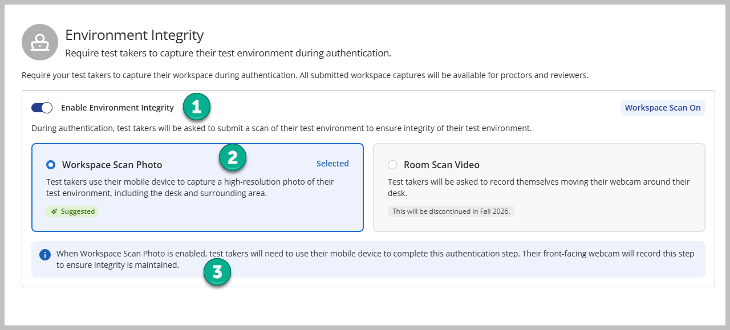
Online@JSU recognizes that allowing a mobile device into the testing environment can cause security concerns, and Honorlock does as well. Therefore, even though this option is enabled, without the mobile device option, students can still elect to use the webcam to complete the environment integrity scan. Selecting this option is demonstrated in the authentication section of this tutorial.
Review the recommendations in the next section if you do not want students to use a mobile device to complete the workspace scan photo process and would rather they use their webcam to complete it.

Recommendations
If Workspace Scan Photo is selected, we recommend the following guidelines:
- Under Test Taker Guidelines (discussed in the next section of the tutorial), explicitly state that Mobile devices such as smartphones, tablets, watches, and laptops and any other type of mobile device are not allowed in the testing environment. Other secondary devices such as a secondary desktop computer are also not allowed in the testing environment. If secondary devices of any nature other than the testing computer are identified during testing, the instructor will use discretion in accordance with JSU’s academic honesty policy to deduct points from the test.
- Require students to use either an external webcam or built-in PC/Mac webcam to record their testing environment and explicitly state these instructions under Test Taker Guidelines. An external webcam is recommended.
- Provide detailed instructions to students before the exam that demonstrates which option they are required to select during the authentication process. (These instructions are provided later under Authentication Process.)
- Remind students that all students at Jacksonville State University are expected to adhere to the Academic Honesty policy located within the Scholar's Code.

Test Taker Guidelines
Test taker guidelines allow faculty to clearly communicate what students are permitted and prohibited from doing during a testing session. They also provide an opportunity for faculty to include specific instructions or expectations for students to follow during the exam. The options are:
- Open Book Allowed
- Notes Allowed
- Scratch Paper Allowed
- Restroom Breaks Allowed
- Handheld Calculator Allowed
- Headphones Allowed
- Hats Allowed
- Public Area Allowed
- Background Noise Allowed
- Mobile Phone Use Allowed
- Show Additional Instructions – allows faculty to provide explicit instructions as to what is allowed or not allowed to occur during the exam.
Typically, students are expected to complete the test session in a private, secure location.
Click on Show Additional Instructions [11] to type directions into the text box.
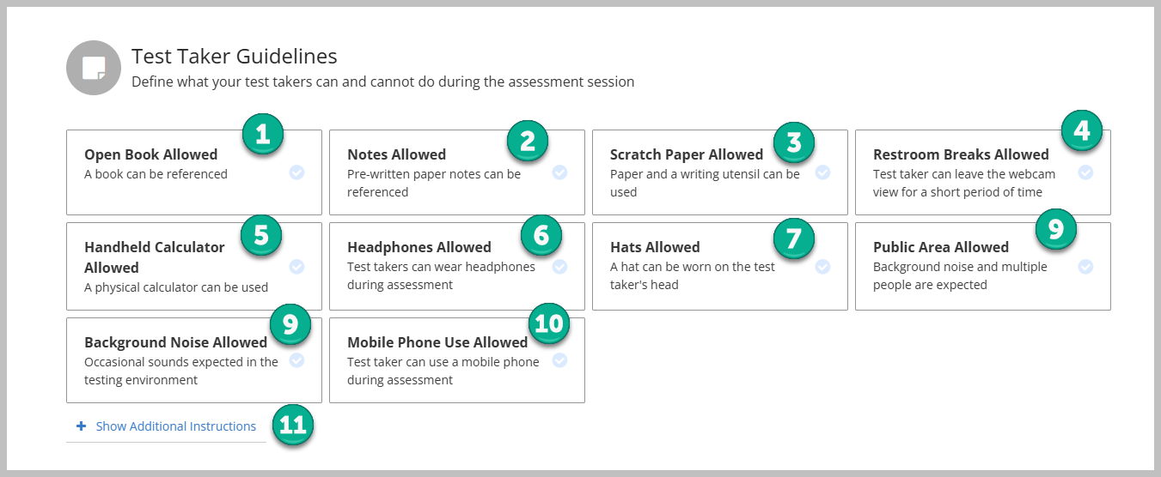
See an example of Additional Instructions related to Workspace Scan that have been entered into Additional Instructions in the Honorlock exam settings. This is how students view them when they start the exam.
- Completing Workspace Scan/Check without a mobile device
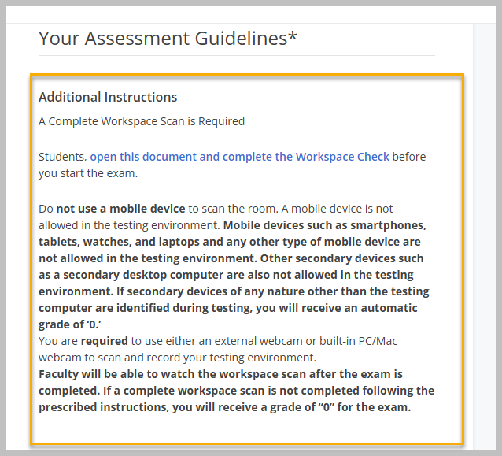

Assessment Accommodations
This section gives faculty the opportunity to detail any potential accommodations for students during the test session. For example, if a student receives specific accommodation during the test session, list the student’s name and the accommodation.
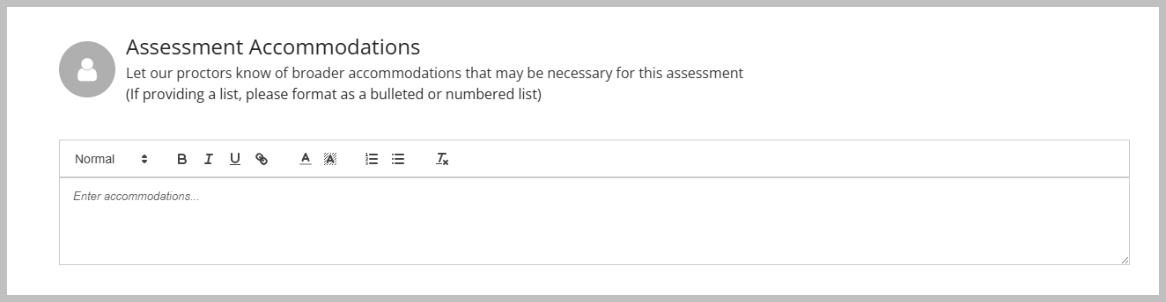
Note: Students do not see this information. Only Honorlock proctors see this information.

Assessment Visibility
By default, this setting is set to “No, use the dates on the assessment to determine test taker view.”
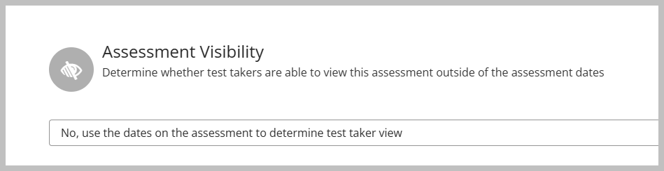

Enable
Click on the Enable button once settings have been completed.
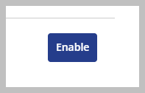
After a quiz is enabled, it will appear on the Honorlock Dashboard with two buttons:
- Results
- Settings
Click on the Results [1] button to view completed student test sessions.

Deploying an Honorlock-Proctored Exam
It is strongly recommended that faculty direct students to access and complete an Honorlock-proctored exam through the Honorlock 1.3 dashboard.

Recommendation
We do not recommend that Honorlock-proctored exams be published in a Module; our office has seen instances in which issues occur if the exam is accessed in the module. Instead, include instructions in the module that direct students to access and complete the exam through the Honorlock 1.3 dashboard.

How Students Access and Complete an Honorlock-Proctored Exam

Launch the Exam
Click on Honorlock 1.3 [1] in the navigation menu. Locate the exam on the Honorlock dashboard and click on the Launch button [2]. The Honorlock authentication process will begin.
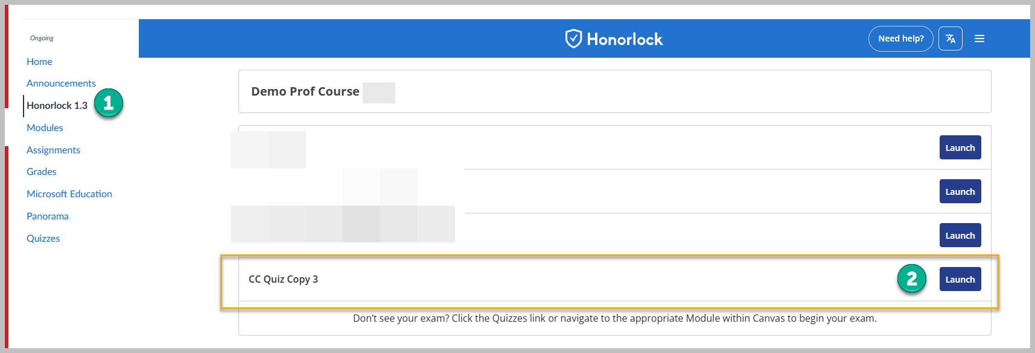
If students do not have the Honorlock Chrome Browser Extension, they will be prompted to download and install it. The Extension is required to complete the exam.

Data Collection & Use
Students are required to check two boxes:
- I agree to authorize the collection of this data [1].
- I agree to Honorlock’s Terms of Service [2].
Once both boxes are checked, they can click on the Continue to System Check button [3].
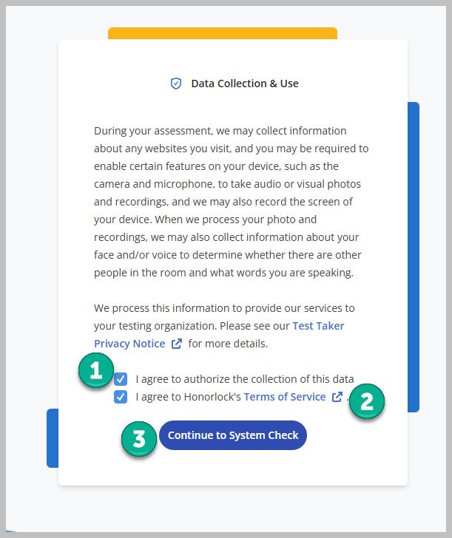

System Compatibility, Your Assessment Guidelines, Review Authentication Settings, and Honorlock Proctoring Prep

System Compatibility
Students can run the system check to ensure that their system is compatible with Honorlock. This step is optional.
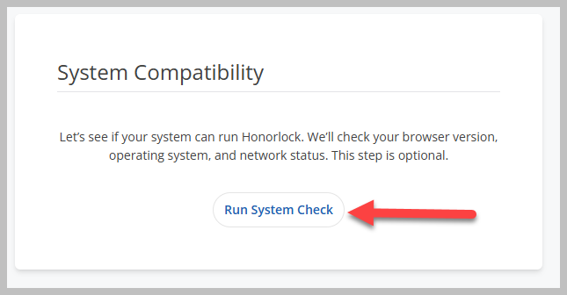
The system compatibility check analyzes the browser, operating system, and network and identifies any issues.
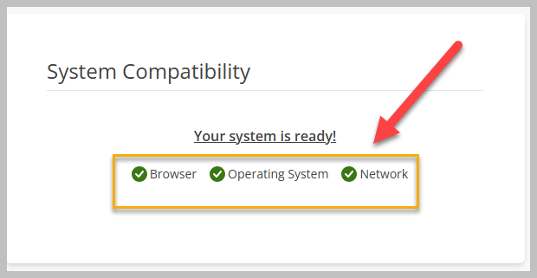

Your Assessment Guidelines
In this section, students will see the guidelines for the exam, including any direct instructions provided during the exam settings setup.
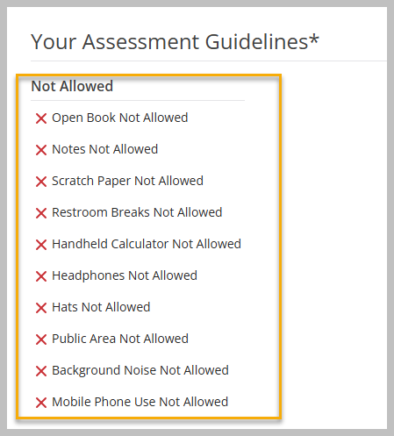

Review Authentication Settings
In this section, students will see whether a workspace scan is required for the exam.
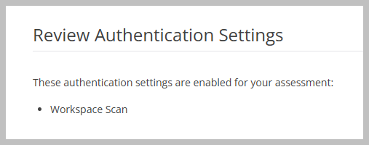

HonorPrep
In this section, students can click on an HonorPrep link to see how Honorlock works during an assessment. Students can view this tutorial before they begin the authorization process.
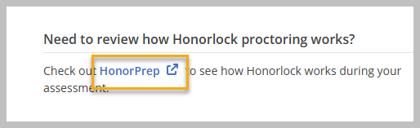
After clicking on the link, click on the Start Guided Tour Button [1].
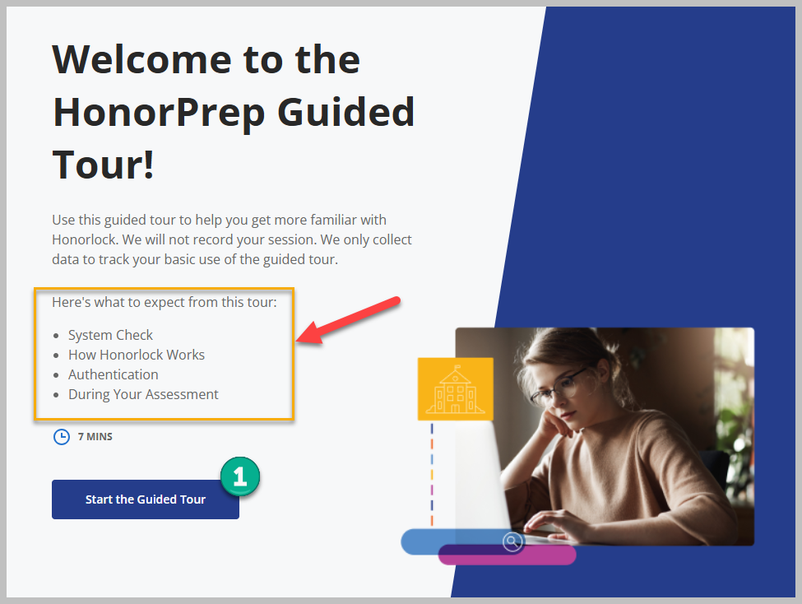
Students will be guided through a tour of how Honorlock works.
This tour, again, is optional.

Begin Authentication
At the bottom of the page, students begin the exam process by clicking on the Begin Authentication button [1].
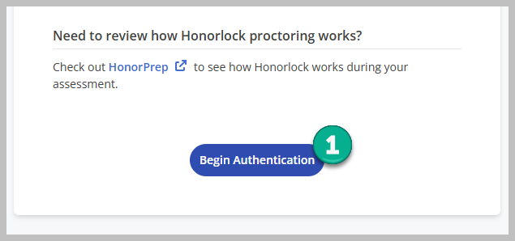

Privacy Details
Students must click on the I Understand button [1] to continue authentication.
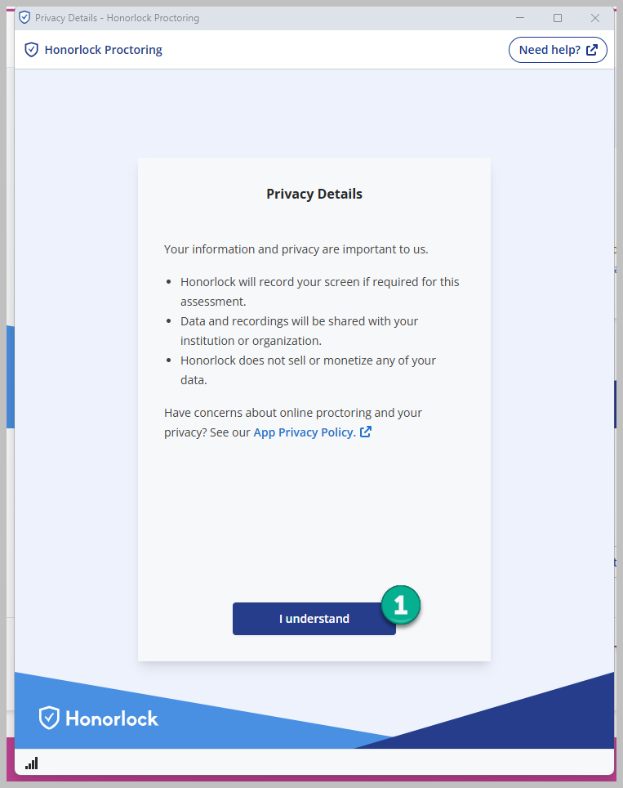
Students will complete various steps to complete the authentication process, depending on the settings selected during exam creation.
Learn more about the authentication process from the student perspective by visiting How to Complete ID verification from Honorlock resources.

Workspace Check
Beginning September 1, the Legacy Room Scan Video option will no longer be selectable in the same location in Settings. Honorlock is incorporating this legacy feature into the Workspace Scan Photo student workflow. Enabling Environment Integrity and Workspace Scan Photo will provide students with the opportunity to choose Room Scan Video at the appropriate point in their workflow.
Faculty who elect to allow students to use a mobile device to complete a Workspace Scan should review the Workspace Scan for Authentication - Admin Guide provided by Honorlock.

Instructions to Complete a Room Scan Video for Authentication without a Mobile Device

In this section, we will demonstrate the instructions that faculty should provide to students when completing a Workspace Check without a mobile device in the testing environment.
Students, complete the Workspace Check by following these steps:
- Prepare your workspace by completing these three steps, and then click on the checkbox beside each one to confirm each step has been completed.
  - I’m taking my assessment at a table or desk.
  - I have removed clutter from my workspace.
  - I’m only using materials and devices that are allowed by my assessment.
- Then click on the Continue button.
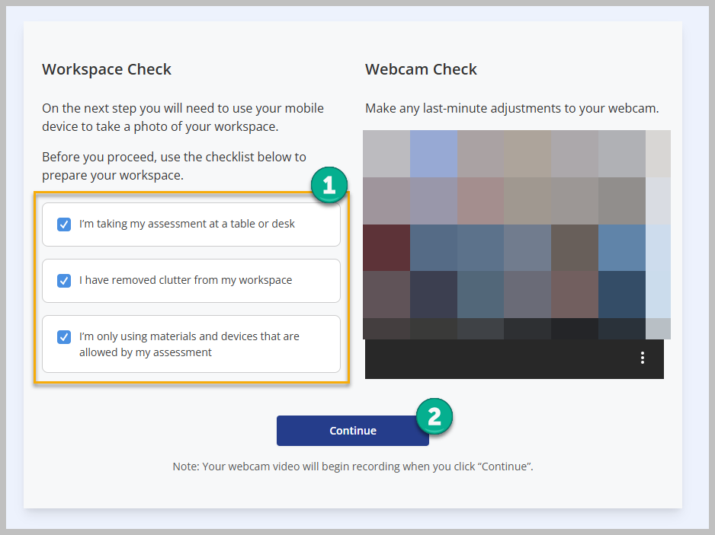
  - Do not use a mobile device to scan the room. A mobile device is not allowed in the testing environment. Mobile devices such as smartphones, tablets, watches, and laptops and any other type of mobile device are not allowed in the testing environment. Other secondary devices such as a secondary desktop computer are also not allowed in the testing environment. If secondary devices of any nature other than the testing computer are identified during testing, the instructor will use discretion in accordance with JSU’s academic honesty policy to deduct points from the test.
  - You are required to use either an external webcam or built-in PC/Mac webcam to record your testing environment. An external webcam is recommended.
- At the bottom of the screen, select Click here to submit a room scan video instead.
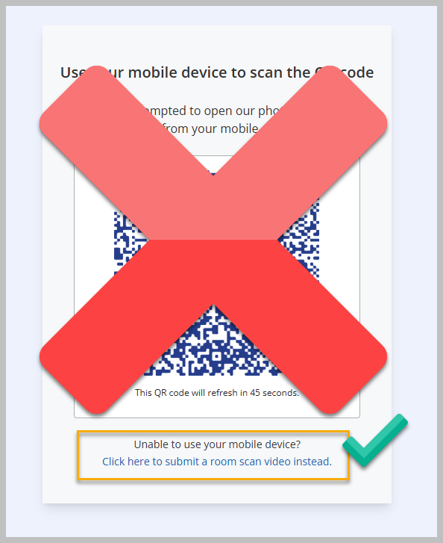
- Click on the Start Room Scan button. Use an external webcam or the internal webcam on your laptop/Mac to scan the room (testing environment). An external webcam is recommended.
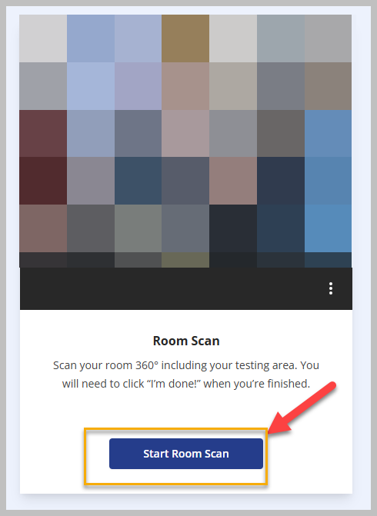
- The room scan process will begin. Use your webcam to complete a 360-degree scan of your desk, room, and testing environment. Scan the entirety of the workspace, including under your desk and behind your desk. When you are finished, click on the I’m Done! button.
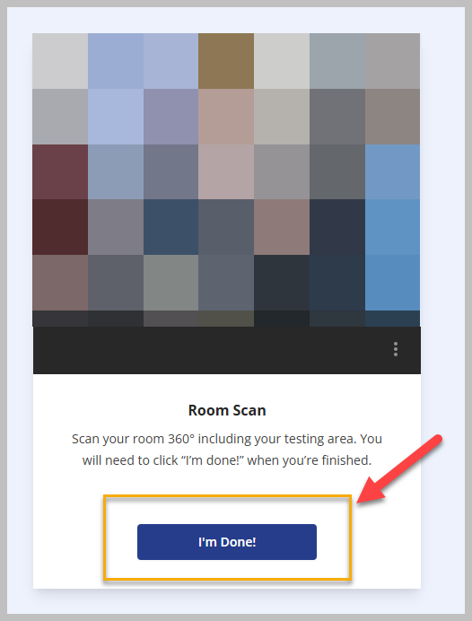
- You can watch and review your room scan before you submit it. Watch the scan. If the scan captured your workspace, click on the Yes, Submit button [1]. If it did not capture your workspace, click on No, Try Again [2] and complete the room scan again. Once complete, click on the Yes, Submit button [1].
  - Faculty will be able to watch the workspace scan after the exam is completed. If a complete workspace scan is not completed following the prescribed instructions, the instructor will use discretion in accordance with JSU’s academic honesty policy to deduct points from the test.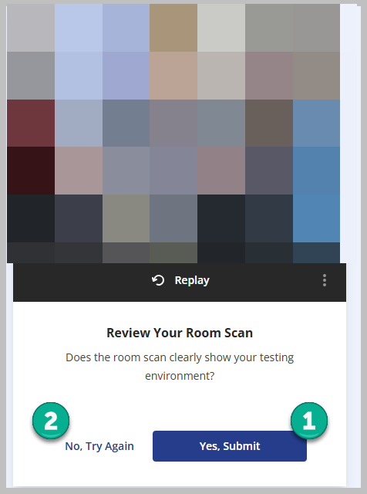

Focus Test Window
Click on the Focus Test Window.
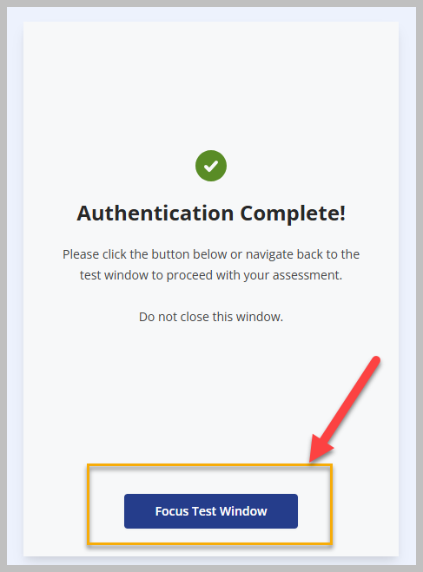

Start Assessment
Click on the Start Assessment button to begin the exam.
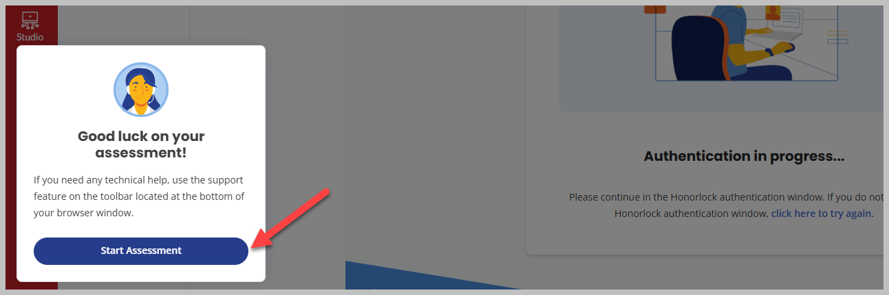

Resources

Honorlock Help Center and 24/7 Support
- Honorlock Support Center
- Honorlock 24/7 Support – Live chat with Honorlock any time

Best Practices and Student Guidelines
- Best Practices for Remote Proctoring
- Honorlock Standard Exam Guidelines for Students

Practice Exams and Third-Party Exams
- Creating a Practice Exam in Canvas
- Creating a Third-Party Exam

Honorlock Features
- Browser Guard and Allowed Site URLs FAQs
- Search & Destroy Guide
- Search & Destroy Guide- Third Party Assessments
- Workspace Scan for Authentication - Admin Guide provided by Honorlock. - If faculty opts to allow students to use a mobile device during the authentication process.

Reviewing Honorlock Test Results
- How to View Your Honorlock Results
- Reviewing Session Results Best Practices
- Navigating A Session in the Session Viewer
- How to Interpret Flags
- Reviewing a Summary Report

Resources for Test Takers
- Test Taker Resources
- Test Taker Quick Fixes – if students run into Honorlock issues
- Workspace Scan - Test Taker Guide (If faculty allow students to use a mobile device to complete authentication (Workspace Check).

Tips, Recommendations, & Best Practices
- Focus on leveraging Honorlock on high-stakes tests and exams.
- When Honorlock is enabled with a Canvas Quiz, it adds an access code in the student access code area under Settings (New Quizzes) and an access code in the access code area under the quiz settings (Quizzes). This code does not appear to students. The code connects Honorlock to the Canvas Quiz. Editing, changing, or deleting the code will remove Honorlock from the Quiz. Do not change or edit the code, and do not provide the code to students.
- Instruct students to access and complete exams from the Honorlock 1.3 link in the course navigation menu, rather than accessing the exam within a Module, on the Assignments index page, or Quizzes index page.
- Regarding exam instructions, be as specific and as detailed as possible when describing what students are allowed to do and not allowed to do. This includes specifications regarding what is acceptable or unacceptable in the physical environment/location in which they are testing. When possible, students should be in a private location with a clear workspace.
- Make it clear that mobile devices are not allowed in the testing area. Provide the Workspace Scan instructions to students prior to the exam.
- Create an Honorlock Practice Assessment and make it available to students at least one week prior to the actual test session.
- Often, faculty are concerned about student violations of academic integrity during a test session.
  - Quiz Settings: These quiz settings should be considered when mitigating student violations. In the quiz settings, select the following:
    - Shuffle questions
    - Shuffle answers
    - Enable one question at a time
    - Enable Time limit
      - Consider assigning 30 seconds to 1 minute for multiple choice, True/False, and fill-in-the blank questions.
    - Enable Detect Multiple Sessions
  - Question Creation:
    - Consider creating open-ended application questions that require students to apply course content to explaining or solving a problem rather than multiple choice, True/False, and fill-in-the-blank questions.
    - In New Quizzes, consider using the Stimulus question type. Stimulus content gives students a piece of content with associated questions, similar to how questions often appear on standardized and professional licensure tests. Learn more about Stimulus Questions.
    - Update quiz questions (and question banks) every semester. Try not to rely on the exact same questions from term to term. Often, small edits are effective.

Online@JSU
We are Online@JSU.
Online@JSU is a dedicated team of instructional designers and technical specialists focused on supporting all aspects of online education. Our services range from providing around-the-clock technical assistance to online students to helping instructors develop and deliver the highest quality, most engaging and effective online classes possible.
Web: jsu.edu/online | Email: online@jsu.edu | Phone: 256.782.8172 |
Operating Hours: Monday-Friday, 8:00 am – 4:30 pm (excluding university and holiday closures)

