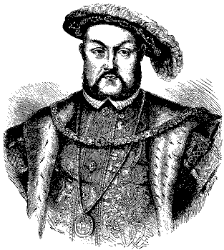
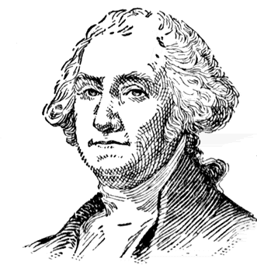
JSU
History Club
Membership Application

Name: *______________________________________________________

University Address: ____________________________________________

Phone Number: _______________________________________________

Home Address: _____________________City: _______________________

State: _____________________ Zip Code: __________________

E-Mail Address: *______________________________________________

Major: ________________________ Minor: ________________________

Hours of History Completed: _____________________________________

List of History Courses Completed: ________________________________
_______________________________________________________________________________________________________________________________________________________________________________________

Historical Areas of Interest: _____________________________________
__________________________________________________________________________________________________________________________
* Areas that must be filled out.

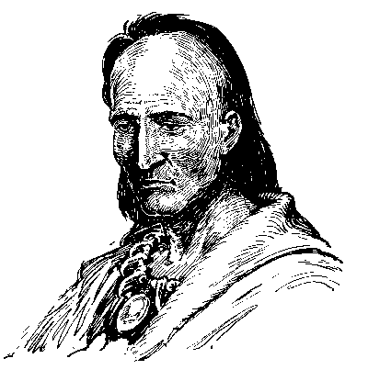


Fill out this application and take it to Dr. Cook in 318 Stone Center.

