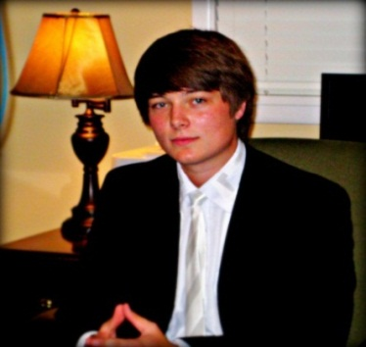
Jansen Harmon, President
Honors Scholars Board

No one is more excited about this semester than I am! It is a great honor to be a part of an up-and-coming organization like JSU’s Honors Program.
Even though we are a relatively new organization, we are undertaking some impressive projects. I encourage all of you to get involved in your Honors Program and remember that we are always pursuing excellence.

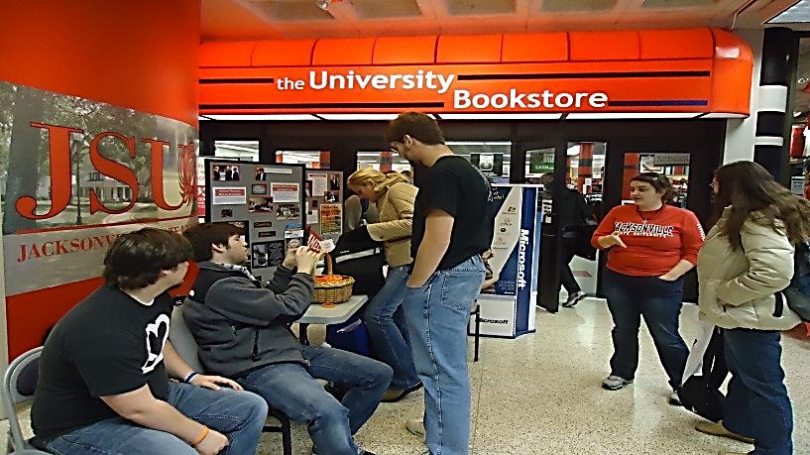
On February 1 the Elite Honors Students sold bracelets at the TMB to raise money for United Cerebral Palsy.

2009-2010 Elite Honors Students
Allison Clark
Courtney Crosby
Michael Greenwood
Jansen Harmon
Kristin Hays
Andrew Newsome
Benjamin Parr
Joshua Wise

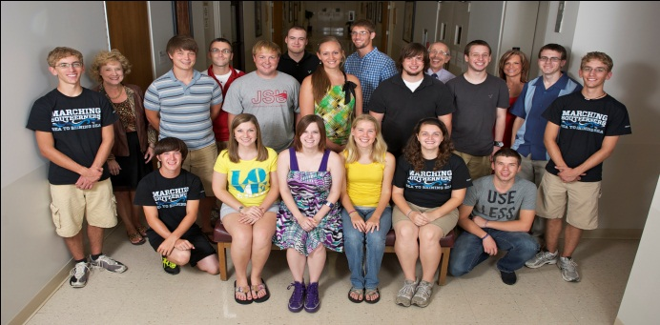

2010-2011 Elite Honors Students
Cody Coots
Gregory Felch
Whitney Gaut
Brian Hinkemeyer
Terry Hinkemeyer
Evan Mince
Emilee Smith
Joshua Truitt

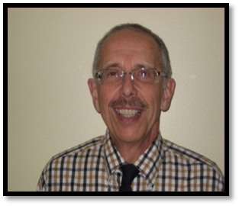
As we gear up for Spring 2011, we should be excited about the old and the new.
We are pleased that the Shoes for Spring initiative continues. Our boxes will be in all academic buildings for collecting shoes for the needy in our community.
Our new spring project will center around the book Year of Our Lord, written by T. R. Pearson, which focuses on the life of Lucas McCarty, who suffers from cerebral palsy. The author, numerous associates, and the subject of the book will be on campus during the spring. We plan fundraising to benefit United Cerebral Palsy of Calhoun County, including sales of restaurant cards and commemorative silicon bracelets.
-Dr. Steven J. Whitton
Honors Board

Dr. Steven Whitton
Director, Honors Program
Professor of English
Dr. Aaron Garrett
Assistant Professor of Computer Science
Mr. Andrew C. Green
Director of Enrollment Management
Dr. Gordon Harvey
Professor of History
Ms. Janet Pierce
Honors Program Coordinator
Dr. Teresa Reed
Professor of English
Ms. Lisa Williams
Associate Dean
College of Arts and Sciences

Honors Program Staff
Dr. Steven J. Whitton, Director (256) 782-5640
swhitton@jsu.edu
Ms. Janet Pierce, Coordinator (256) 782-5696
jpierce@jsu.edu

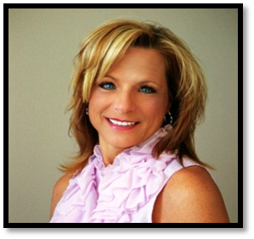
I am excited about being a part of JSU’s Honors Program. I consider it a privilege to be working with such talented and committed students as well as supportive and dedicated staff members. The focus of the program is encouraging every student to fulfill their potential in order to become successful leaders in the community.
Year of our Lord Capstone event is all about striving to promote awareness of cerebral palsy to our student body and community.
I encourage all Honors students to take advantage of the benefits you have by utilizing the Honors House and computer lab. Also, please encourage all Honors students to be a part of the JSU Honors Program.
-Janet Pierce
HONORS PROGRAM CALENDAR
Honors Scholars Board Meeting
Tuesday, March 8
5:30 at the Honors House
S.H.O.E Project
February
Spring Break
March 14-18
“Year of Our Lord” Capstone Event
March 30
Preview Day
Saturday, April 2
9:30 – 12:00

